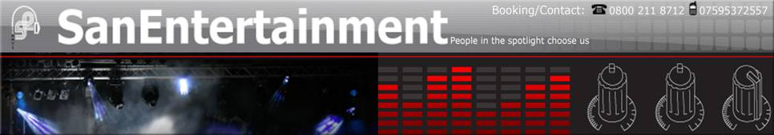

Entertainer Biography

The Blossom Street Singers

The Blossom Street Singers is a dynamic vocal octet of highly trained professional singers, all in their twenties. The group performs a very wide range of music which is tailored to the audience or venue - from jazz and pop arrangements to close harmony to well-loved classical favourites. A typical programme might include popular classics like Elgar’s Nimrod and Barber’s Adagio, alongside jazz standards and the theme tunes to Austin Powers and Friends. In December 2005, Blossom Street filmed a medley of Christmas carols for BBC2, which was broadcast during the snooker championship final; since then they have performed nationwide.

Depending on your requirements, Blossom Street can provide between four and eight singers for concerts, events or private functions. The group’s versatility makes it an ideal choice for weddings; perhaps providing classical, religious or spiritual music during the ceremony and lively pop and jazz arrangements at the reception. Similarly at corporate events, Blossom Street can either perform a range of easy listening background music or provide the main entertainment of the evening, with sparkling renditions of popular hits. Either way, this adds a unique and special feel to any function.

Blossom Street was established in 2003 by Hilary Campbell, who gained a distinction for her MA in Vocal Studies at the University of York and subsequently took up a postgraduate place at Trinity College of Music. Hilary directs the ensemble and sings soprano. Other members of the group, many of whom are Oxbridge graduates, also sing with prestigious professional choirs such as the BBC Singers and the Monteverdi Choir.

Although based in London, the singers are willing to travel

The Music

We have an extensive song catalogue that we are able to perform at your event. The music has been carefully chosen and manipulated by our musical director to ensure an amazing audio experience.
- Here is a brief list of songs we perform, for a more detailed list please contact us.
Pop and Jazz arrangements include:
Goodnight Sweetheart
I’ll be There for You (Friends theme tune)
Is You Is or Is You Ain’t My Baby?
Lullaby of Birdland
Miss Otis Regrets
Rescue Me*
Satin Doll
Sit Down You’re Rockin’ the Boat
Son of a Preacher Man*
Soul Bossa Nova (Austin Powers theme tune)
The Way You Look Tonight
That Lonesome Road
Whiter Shade of Pale
Why do Fools Fall in Love?

- Beatles Songs include:
Can’t Buy Me Love
Eleanor Rigby
Honey Pie
I Feel Fine
Michelle
When I’m Sixty Four
Yesterday

- Popular Classics include:
Barber’s Adagio
Bruckner’s Locus Iste
Elgar’s Nimrod
Finzi’s My Spirit Sang All Day
Gorecki’s Totus Tuus
Purcell’s Hear My Prayer
Stanford’s The Blue Bird

- Music for Weddings includes:
Bach’s Jesu, Joy of Man’s Desiring*
Chilcott’s Irish Blessing
Delibes’ Flower Duet*
Fauré’s Cantique de Jean Racine*
Franck’s Panis Angelicus
Mozart’s Ave Verum*
Mozart’s Laudate Dominum*
Rutter’s For the Beauty of the Earth
Rutter’s God Be in My Head
Schubert’s Ave Maria*
Stanford’s Beati Quorum Via
Tallis’ If Ye Love Me

- Contemporary and other classical music includes:
Elgar’s My Love Dwelt in a Northern Land
Ireland’s The Hills
Lauridsen’s O Magnum Mysterium
Parry’s Never Weather-Beaten Sail
Pearsall’s Lay a Garland
Tippett’s Spirituals
Vasks’ Three Poems
Vaughan Williams’ Silence and Music
Whitacre’s Water Night

* With piano accompaniment

